Experiment 1
AIM: Flashing of LED using AT89C51 Microcontroller using Proteus
Objective:
- To interface an LED with the AT89C51 microcontroller in the Proteus simulation environment.
- To write and execute a program for blinking the LED at regular time intervals.
- To understand the use of digital output ports and delay generation in the AT89C51.
Program:
ORG 0000H
UP: SETB P2.0
ACALL DELAY
CLR P2.0
ACALL DELAY
SJMP UP
DELAY: MOV R4,#35
H1:MOV R3,#255
H2:DJNZ R3,H2
DJNZ R4,H1
RET
END
OUTPUT:
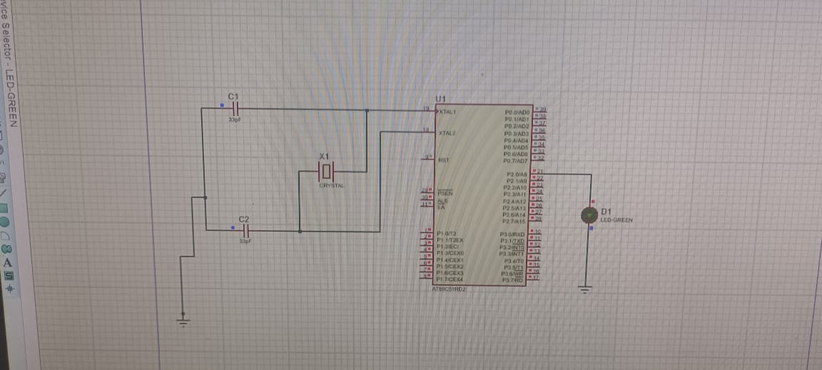
Experiment 2
AIM: Generation Of Square Wave Using Proteus
Objective:
- To generate a square wave using one of the output pins of the AT89C51 microcontroller.
- To simulate the square wave generation using Proteus and observe the output waveform.
- To understand timer/delay concepts used for waveform generation in embedded systems.
Program:
ORG 0000H
UP: SETB P2.0
ACALL DELAY
CLR P2.0
ACALL DELAY
SJMP UP
DELAY: MOV R4,#35
H1:MOV R3,#255
H2:DJNZ R3,H2
DJNZ R4,H1
RET
END
OUTPUT:
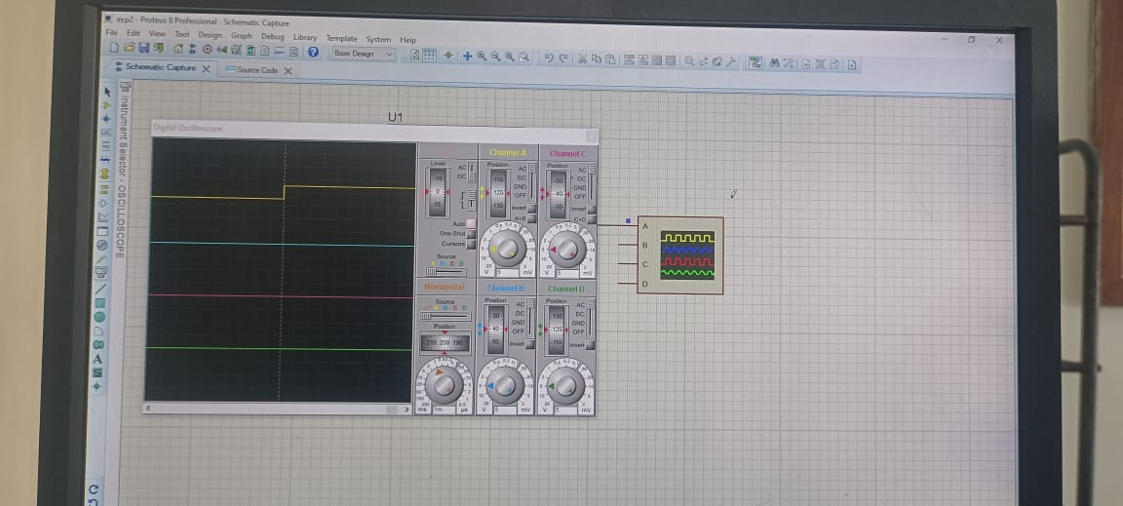
Experiment 3
AIM: Stepper Motor Using At89c51 Using Proteus
Objective:
- To interface a stepper motor with the AT89C51 microcontroller using Proteus.
- To develop a program to rotate the stepper motor in a specified sequence.
- To understand the stepping sequence and control of stepper motors using a microcontroller.
Program:
ORG 0000H
UP: MOV P2,#09H
ACALL DELAY
MOV P2,#0CH
ACALL DELAY
MOV P2,#06H
ACALL DELAY
MOV P2,#03H
ACALL DELAY
SJMP UP
DELAY:MOV R4,#18
H1:MOV R3,#255
H2:DJNZ R3,H2
DJNZ R4,H1
RET
END
OUTPUT:
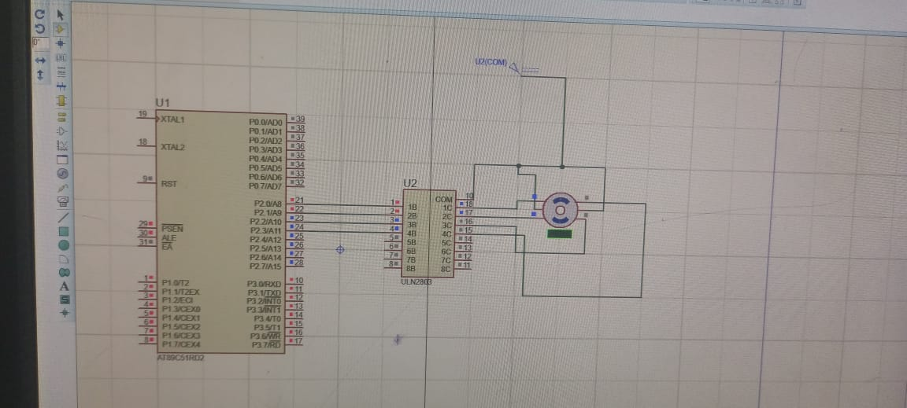

Experiment 4
AIM: 7 Segment Display Using At89c51 Using Proteus
Objective:
- To interface a 7-segment display with the AT89C51 microcontroller in Proteus.
- To write a program to display numeric digits on the 7-segment display.
- To understand the working of LED display interfacing and digital output control using the AT89C51.
Program:
ORG 000H
UP:MOV P2,#0C0H
ACALL DELAY
MOV P2,#0F9H
ACALL DELAY
MOV P2,#0A4H
ACALL DELAY
MOV P2,#0B0H
ACALL DELAY
MOV P2,#99H
ACALL DELAY
MOV P2,#92H
ACALL DELAY
MOV P2,#82H
ACALL DELAY
MOV P2,#0F8H
ACALL DELAY
MOV P2, #80H
ACALL DELAY
MOV P2,#90H
ACALL DELAY
DELAY: MOV R5,#10
H1:MOV R4,#180
H2:MOV R3,#255
H3:DJNZ R3,H3
DJNZ R4,H2
DJNZ R5,H1
RET
END
OUTPUT:
